LAB ASSIGNMENT:01

NAME :Bhavana.Pommedi

ROLLNO :2403A54069

BATCH :03

Lab 1: Environment Setup – GitHub Copilot and VS Code Integration

**Lab Objectives:**

* To install and configure GitHub Copilot in Visual Studio Code.
* To explore AI-assisted code generation using GitHub Copilot.
* To analyze the accuracy and effectiveness of Copilot's code suggestions.
* To understand prompt-based programming using comments and code context

**Lab Outcomes (LOs):**

After completing this lab, students will be able to:

* Set up GitHub Copilot in VS Code successfully.
* Use inline comments and context to generate code with Copilot.
* Evaluate AI-generated code for correctness and readability.
* Compare code suggestions based on different prompts and programming styles.

Task 0

* Install and configure GitHub Copilot in VS Code. Take screenshots of each step.

Expected Output

* Install and configure GitHub Copilot in VS Code. Take screenshots of each step.
* 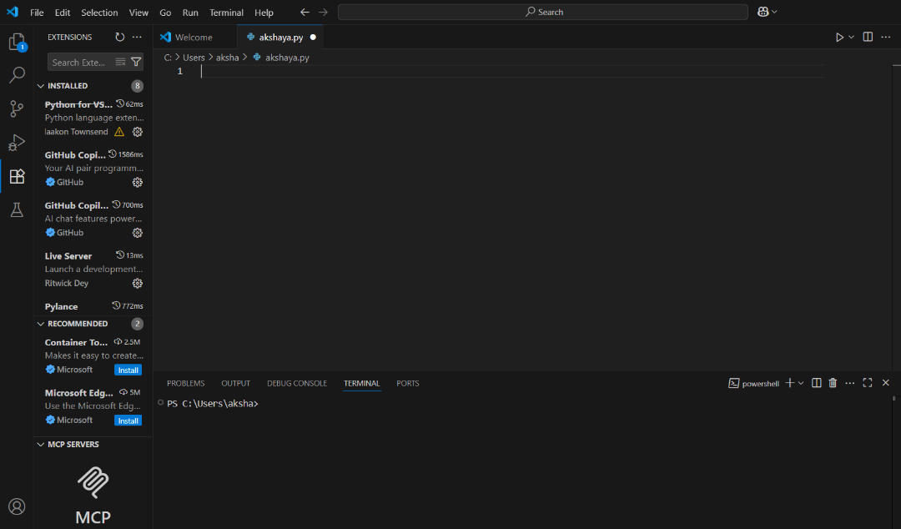

Task 1: Factorial without Functions

* Description:  
  Use GitHub Copilot to generate a Python program that calculates the factorial of a number without defining any functions (using loops directly in the main code).
* Expected Output:
  + A working program that correctly calculates the factorial for user-provided input.
  + Screenshots of the code generation process.
  + 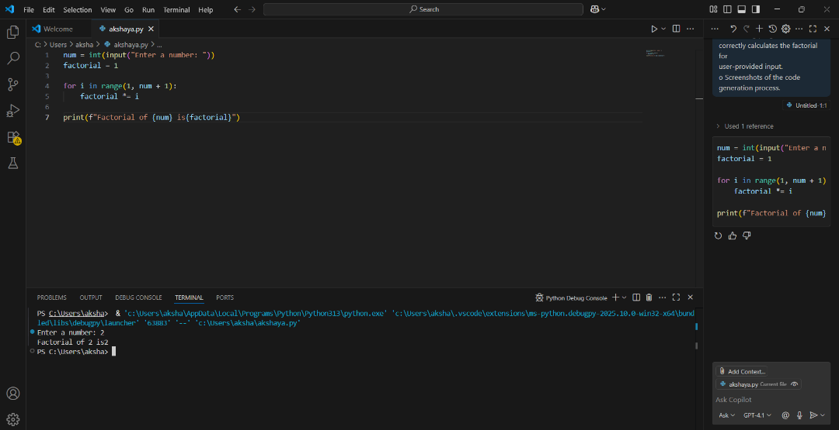

Task 2: Improving Efficiency

* Description:  
  Examine the Copilot-generated code from Task 1 and demonstrate how its efficiency can be improved (e.g., removing unnecessary variables, optimizing loops).
* Expected Output:
  + Original and improved versions of the code.
  + Explanation of how the improvements enhance performance.
  + 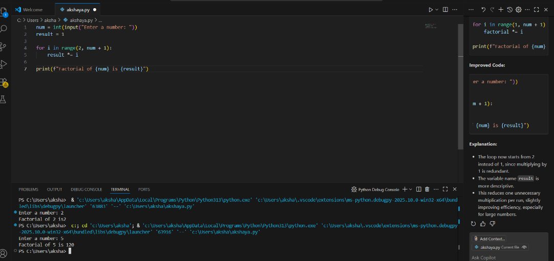

Task 3: Factorial with Functions

* Description:  
  Use GitHub Copilot to generate a Python program that calculates the factorial of a number using a user-defined function.
* Expected Output:
  + Correctly working factorial function with sample outputs.
  + Documentation of the steps Copilot followed to generate the function.
  + 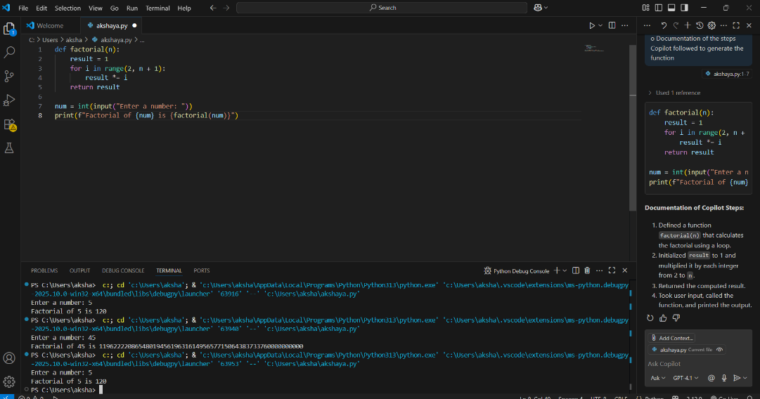

Task 4: Comparative Analysis – With vs Without Functions

* Description:  
  Differentiate between the Copilot-generated factorial program with functions and without functions in terms of logic, reusability, and execution.
* Expected Output:
  + A comparison table or short report explaining the differences.
  + 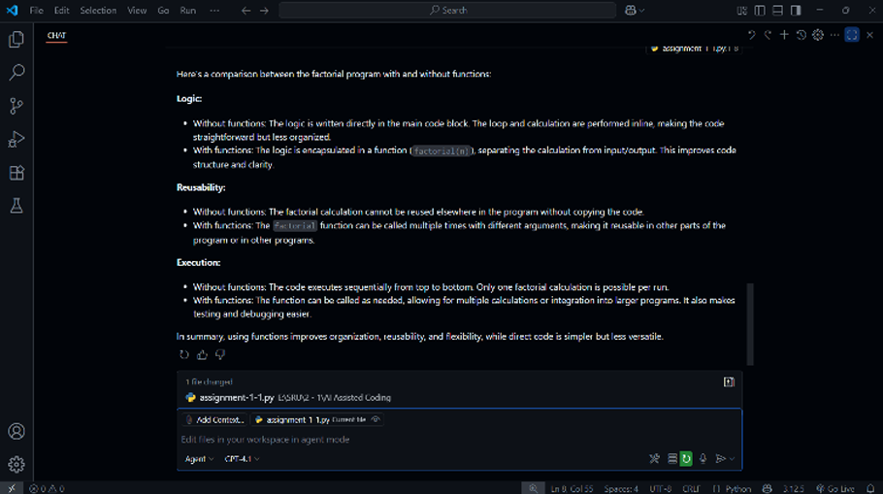

Task 5: Iterative vs Recursive Factorial

* Description:  
  Prompt GitHub Copilot to generate both iterative and recursive versions of the factorial function.
* Expected Output:
  + Two correct implementations.
  + A documented comparison of logic, performance, and execution flow between iterative and recursive approaches.
  + 